
WILLETTON SENIOR HIGH SCHOOL

SEMESTER ONE 2015 EXAMINATION
Question/Answer Booklet

PSYCHOLOGY
Stage 3

Student Name: _______________________________________________

Time allowed for this section
Reading time before commencing work: 10 minutes
Working time for this section: 3 hours

Materials required/recommended for this section
To be provided by the supervisor
This Question/Answer Booklet

To be provided by the candidate
Standard items: Pens, pencils, pencil sharpener, eraser, correction fluid, ruler, highlighters
Special items : Calculators satisfying the conditions set by the Curriculum Council for this course

Important note to candidates

No other items may be used in this section of the examination. It is your responsibility to ensure that you do not have any unauthorised notes or other items of a non-personal nature in the examination room. If you have any unauthorised material with you, hand it to the supervisor before reading any further.
STRUCTURE OF THIS PAPER

Section | Suggested working time | Number of questions available | Number of questions to be answered | Marks | % weighting | Raw Score | % Score
Section One:  Research Methods | 30 minutes | 3 | 3 | 30 | 20 | 30 | %
Section Two:  Short Answer | 90 minutes | 5 | 5 | 74 | 55 | 74 | %
Section Three:  Extended Response | 60 minutes | 2 | 2 | 50 | 25 | 50 | %
 |  |  | Total Marks | 145 | 100 | 154 | %

PERCENTAGE SCORE: ____________/100

INSTRUCTIONS TO CANDIDATES

- Sitting this examination implies that you agree to abide by the school’s rules for the conduct of examinations.

- Answer all questions by writing your answers in this booklet in the spaces provided.

- You must be careful to confine your responses to the specific questions asked and to follow any instructions that are specific to a particular question.

- Spare answer pages may be found at the end of this booklet. If you need to use them, indicate in the original answer space where the answer is continued (ie give the page number).

SECTION ONE: RESEARCH METHODS (20 marks)

This section has THREE (3) questions.
Attempt ALL questions.

Suggested working time: 30 minutes
_____________________________________________________________________________________

Question 1 (10 marks)

Dr. Parker was interested in determining the relationship between involvement in extracurricular school activities and self-esteem. He collected his data using self-report questionnaires to obtain measures of self-esteem and the number of hours spent on extracurricular school activities per week from 300 high school students who volunteered to participate.

(a) Provide a research hypothesis for this study. (1 mark)

_________________________________________________________________________________

_________________________________________________________________________________

(b) What sampling method was used in this study? (1 mark)

_________________________________________________________________________________

(c) Provide one strength and one limitation of using this method of selecting participants.

- strength: (1 mark)

_________________________________________________________________________________

- limitation: (1 mark)

_________________________________________________________________________________

(d) State one advantage and one disadvantage of the data collection method that Dr. Parker used.

- advantage: (1 mark)

_________________________________________________________________________________

- disadvantage: (1 mark)

_________________________________________________________________________________
Question 1 (continued)

The results of the study are shown in the scattergram below:

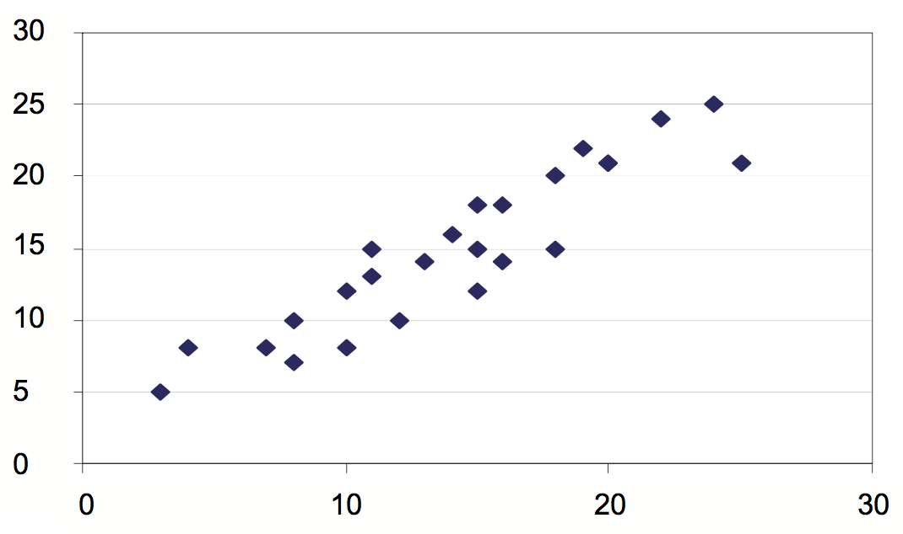

Self –esteem Rating

Average No. of Hours spent on school extracurricular activities per week

(e) (i) Identify the strength and direction of the relationship between the two variables shown in the scattergram. (1 mark)

_________________________________________________________________________________

(ii) Do the results shown in the scattergram support the hypothesis stated in Question 1 (a)? (1 mark)

_________________________________________________________________________________

(f) State a conclusion that Dr. Parker could make based on the results. (1 mark)

_________________________________________________________________________________
_________________________________________________________________________________

(g) Describe a limitation of the research design used in this study that affects the conclusion drawn from the results. (1marks)

_________________________________________________________________________________
_________________________________________________________________________________
Question 2 (14 marks)

Professor Zheng of Brightland University wanted to test whether a vitamin supplement helped to improve students’ grades. To test her idea, she told her class she was giving them all a supplement that would make them smarter. She told them they all had to participate and discussed the details of the experiment with them.
Professor Zheng divided the class into two equal groups. Group A received the vitamin supplement and Group B received an inactive substance (sugar pill).
Over the two-week trial, Professor Zheng spent a lot of time with the students gathering data. She was excited to find that the results showed that all students’ grades had improved. She concluded that the vitamin supplement had worked.

(a) Identify

(i) the independent variable for this study. (1 mark)

______________________________________________________________________________

(ii) the dependent variable for this study. (1 mark)

______________________________________________________________________________

(b) Provide an operational hypothesis for this study. (2 marks)

_________________________________________________________________________________

_________________________________________________________________________________

_________________________________________________________________________________

_________________________________________________________________________________

(c) Identify a right of the participants that Dr. Zheng overlooked in her research. (1 mark)

_________________________________________________________________________________

(d) (i) Identify the term that refers to a substance with no known medical effects used as a control in an experiment. (1 mark)
_________________________________________________________________________________

Question 2 (continued)

(ii) Explain why Professor Zheng gave one group a substance with no known medical effects. (1 mark)
_________________________________________________________________________________

(e) (i) What do research psychologists mean when they describe research results as valid? (1 mark)

_________________________________________________________________________________

_________________________________________________________________________________

(ii) Was Professor Zheng’s conclusion valid? _______________ (Yes or No) (1 mark)

(iii) Why / why not? Explain your answer. (3 marks)

_________________________________________________________________________________

_________________________________________________________________________________

_________________________________________________________________________________

_________________________________________________________________________________

_________________________________________________________________________________

_________________________________________________________________________________

(f) (i) Identify one source of error in the design of this experiment. (1 mark)

_________________________________________________________________________________

_________________________________________________________________________________

(ii) Describe how you can modify the experiment to eliminate or minimize the effect of the source of error identified above [ (f) (i) ] (1 mark)

_________________________________________________________________________________

_________________________________________________________________________________

_________________________________________________________________________________

Question 3. (6 Marks)

(a) When is it acceptable to use deception in psychological research? (1 mark)

_________________________________________________________________________________

_________________________________________________________________________________

_________________________________________________________________________________

(b) When deception is used, what action should a psychologist take with the participants at the conclusion of the research? (1 mark)

_________________________________________________________________________________

_________________________________________________________________________________

(c) Outline two pieces of information about a research study that a researcher must provide to participants before they can give informed consent. (2 marks)
_________________________________________________________________________________

_________________________________________________________________________________

_________________________________________________________________________________

_________________________________________________________________________________

_________________________________________________________________________________

_________________________________________________________________________________

(d) Who provides informed consent when a participant is less than 18 years of age? (1 mark)

_________________________________________________________________________________

(e) Confidentiality is an ethical issue that is strictly upheld in all research involving human participants. Give one (1) important reason why this is done. (1 mark)

_________________________________________________________________________________

_________________________________________________________________________________

SECTION TWO. SHORT ANSWER ( Marks)

This section has FIVE (5) questions. Attempt ALL questions.
_____________________________________________________________________________________

Question 4: Biological Influences (14 marks)

(a) Given below is a diagram summarizing the main parts of the nervous system. Provide the missing information. (4 marks)
Nervous System
C________ Nervous System
P____________ Nervous System
3. ______________________
1. _______________
2.________________
4. ________________
5. __________________________ (responsible for normal body functions)
6. _________________________ (responsible for aroused response)

(b) Name the four lobes of the cerebrum and state the function of each lobe. (4 marks)

Lobe of the Brain | Function
Question 4 (Continued)

(c) Explain the significance of research involving animals to the understanding of the anatomy and physiology of the human brain. (2 marks)

_________________________________________________________________________________

_________________________________________________________________________________

_________________________________________________________________________________

_________________________________________________________________________________

_________________________________________________________________________________

_________________________________________________________________________________

(b) Describe the role of Broca’s and Wernicke’s Area in speech and language. (2 marks)

_________________________________________________________________________________

_________________________________________________________________________________

_________________________________________________________________________________

_________________________________________________________________________________

_________________________________________________________________________________

_________________________________________________________________________________

(d) Describe two effects of exercise on the nervous system. (2 marks)
_________________________________________________________________________________

_________________________________________________________________________________

_________________________________________________________________________________

_________________________________________________________________________________

_________________________________________________________________________________

_________________________________________________________________________________
Question 5. Personality (14 marks)

(a) How do psychologists define ‘personality’?. (1 mark)

_________________________________________________________________________________

_________________________________________________________________________________

_________________________________________________________________________________

(b) Psychologists have different interpretations of what factors contribute to personality. Some say it is heredity, others say it is the environment. Explain what determines personality according to each of the following theories.

(i) Trait theory (2 marks)

_________________________________________________________________________________

_________________________________________________________________________________

_________________________________________________________________________________

_________________________________________________________________________________

(ii) Humanistic theory (2 marks)

_________________________________________________________________________________

_________________________________________________________________________________

_________________________________________________________________________________

_________________________________________________________________________________

(iii) Psychodynamic theory (2 marks)

_________________________________________________________________________________

_________________________________________________________________________________

_________________________________________________________________________________

_________________________________________________________________________________
Question 5. (continued)

(c) Describe one way in which an understanding of personality is useful to a Year 12 student. (1 mark)
_________________________________________________________________________________

_________________________________________________________________________________

_________________________________________________________________________________

_________________________________________________________________________________

(d) Describe the method used by the following theorists for measuring personality. (6 marks)

Personality Theorist | Description of Method for measuring Personality
Hans Eysenck
Carl Rogers
McCrae & Costa

Question 6. Social Psychology (14 marks)

(a) Psychologists describe group behaviour using the following terms. Define each.

(i) Brainstorming (1 mark)
_________________________________________________________________________________

_________________________________________________________________________________

(ii) Cooperation (1 mark)
_________________________________________________________________________________

_________________________________________________________________________________

(iii) Competition (1 mark)
_________________________________________________________________________________

_________________________________________________________________________________

(iv) Deindividuation (1 mark)
_________________________________________________________________________________

_________________________________________________________________________________

(v) Social loafing (1 mark)
_________________________________________________________________________________

_________________________________________________________________________________

Question 6 (continued)
(b) Sandra is waiting in a long line at the supermarket checkout to pay for a box of chocolates. Sandra is tapping her foot quickly and sighing loudly. An onlooker observes Sandra’s behaviour and thinks that she is a quick-tempered person.
(i) Explain, using attribution theory, why the onlooker is likely to think this. (2 marks)
_________________________________________________________________________________

_________________________________________________________________________________

_________________________________________________________________________________

_________________________________________________________________________________

_________________________________________________________________________________

_________________________________________________________________________________

(ii) Describe one alternative attribution for Sandra’s behaviour. (1 mark)
_________________________________________________________________________________

_________________________________________________________________________________

_________________________________________________________________________________

_________________________________________________________________________________

(c) Explain, using attribution theory, how differences in attributions that people make can lead to conflict.
(2 marks)

_________________________________________________________________________________

_________________________________________________________________________________

_________________________________________________________________________________

_________________________________________________________________________________

_________________________________________________________________________________

_________________________________________________________________________________
Question 6 (Continued)

(d) Describe the ‘state of cognitive dissonance’ according to Festinger’s cognitive dissonance theory.
(2 marks)

_________________________________________________________________________________

_________________________________________________________________________________

_________________________________________________________________________________

_________________________________________________________________________________

_________________________________________________________________________________

_________________________________________________________________________________

(e) According to the cognitive dissonance theory, how can the size of a reward affect one’s state of dissonance? (2 marks)

_________________________________________________________________________________

_________________________________________________________________________________

_________________________________________________________________________________

_________________________________________________________________________________

_________________________________________________________________________________

_________________________________________________________________________________

Question 7. Relational Influences (14 marks)

(a) Two brothers were arguing about who gets to use the family car. Name three different types of solutions that could be used to resolve this conflict and provide one example of each.
(6 marks)

_________________________________________________________________________________

_________________________________________________________________________________

_________________________________________________________________________________

_________________________________________________________________________________

_________________________________________________________________________________

_________________________________________________________________________________

_________________________________________________________________________________

_________________________________________________________________________________

_________________________________________________________________________________

(b) State two reasons why counselling is a better technique for helping partners in a relationship resolve their conflict.
(2 marks)

_________________________________________________________________________________

_________________________________________________________________________________

_________________________________________________________________________________

_________________________________________________________________________________

_________________________________________________________________________________

_________________________________________________________________________________

Question 7. (continued)

(b) Elaine is starting Year 7 at a coeducational high school. Describe how Elaine’s peer relationships are likely to change throughout high school using the first three of Dunphy’s stages of the changing structure of social groups during adolescence,. (6 marks)
_________________________________________________________________________________

_________________________________________________________________________________

_________________________________________________________________________________

_________________________________________________________________________________

_________________________________________________________________________________

_________________________________________________________________________________

_________________________________________________________________________________

_________________________________________________________________________________

_________________________________________________________________________________

Question 8. Developmental Psychology (18 marks)

(a) Name the stage of Piaget’s theory of cognitive development that corresponds to each of the following characteristics (4 marks)

(i) Conservation: ______________________________________________________

(ii) Object permanence: _________________________________________________

(iii) Abstract thinking: ___________________________________________________

(iv) Egocentrism: ______________________________________________________

(b) A psychologist has two glasses that are the same shape and size and are filled with equal amounts of water (see Figure 1). The psychologist pours the water from one glass into a tall thin glass (see Figure 2). The psychologist asks two children whether Glass one or Glass two has more water in it or whether both glasses have the same amount of water. (see Figure 3).
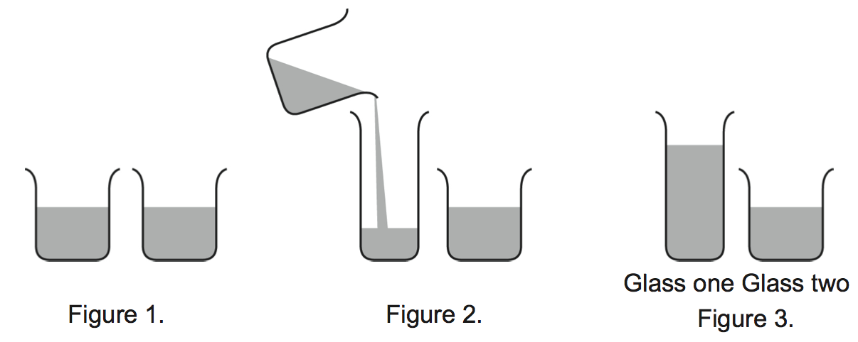

Describe the response that each child would be most likely to give and explain the reason for the response.
(i) Zach (age 4) (2 marks)
_________________________________________________________________________________

_________________________________________________________________________________

_________________________________________________________________________________

_________________________________________________________________________________

_________________________________________________________________________________

Question 8 (Continued)

(b) (ii) Hazel (age 10) (2 marks)

_________________________________________________________________________________

_________________________________________________________________________________

_________________________________________________________________________________

_________________________________________________________________________________

_________________________________________________________________________________

(c) Name the researcher who criticized the conservation task used by Piaget and explain the criticisms given by this researcher. (3 marks)

Name of researcher: _____________________________________

Explanation of criticism:

_________________________________________________________________________________

_________________________________________________________________________________

_________________________________________________________________________________

_________________________________________________________________________________

_________________________________________________________________________________

_________________________________________________________________________________

_________________________________________________________________________________

Question 9 (Continued)

(c) Kohlberg’s theory of moral development described the changes in moral reasoning as one progresses through different stages of development. Describe one feature of moral reasoning that corresponds to each of the following stages. (4 marks)

Stage of Moral Development | Description of moral reasoning
Punishment orientation
Naïve reward orientation
Good Boy/Good girl orientation
Authority orientation

(d) What was Carol Gilligan’s criticism of Kohlberg’s theory of moral development? Outline her interpretation of moral development. (3marks)

_________________________________________________________________________________

_________________________________________________________________________________

_________________________________________________________________________________

_________________________________________________________________________________

_________________________________________________________________________________

_________________________________________________________________________________

_________________________________________________________________________________

_________________________________________________________________________________
SECTION THREE: EXTENDED RESPONSE (50 marks)

This section has TWO (2) questions. You must answer BOTH questions.

Pages are included at the end of the two questions for planning and writing your answers.
- Planning: If you use a page for planning, indicate this clearly at the top of the page.
- Answering the question: In the pages provided indicate clearly the question number you are answering.

Suggested working time: 60 minutes
_______________________________________________________________________________________

Question 9 (25 marks)

Angie overheard her parents talking about how her brother's ADHD medicine was making him less hungry. Because Angie was worried about her weight, she started sneaking one of her brother's pills every few days.
Todd found an old bottle of painkillers that had been left over from his dad's operation. He decided to try them. Because a doctor had prescribed the pills, Todd figured that meant they'd be OK to try.
Excerpt from “Prescription Drug Abuse” www.kidshealth.org

Apply your psychological understandings of the neural transmission process to describe the effect of prescription drugs on the nervous system.

In constructing your extended response, you should:

- label the parts of the diagram provided
- describe the neural transmission process with reference to the diagram you have labeled
- discuss how dopamine and serotonin in the nervous system affect one’s thoughts, feelings and behavior
- explain the effect of a prescription drug on the nervous system (choose one from any of the psychoactive drug groups – stimulants, antidepressants, depressants)
- discuss the short and long term impact of abusing prescription drugs on the individual.

Question No. 9

Using the terms given below, label the figure on the right.

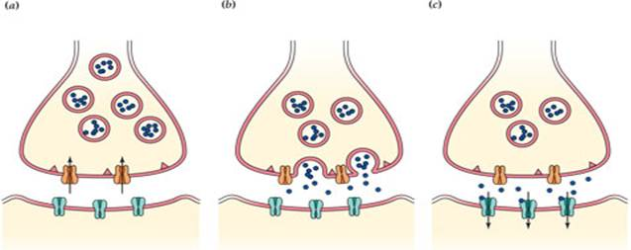
Sending neuron or pre-synaptic neuron.

Receiving neuron or post-synaptic neuron

Vesicles

Neurotransmitters

Synapse

Receptor sites

Transporter proteins

Extended Response:

_______________________________________________________________________________________
_______________________________________________________________________________________
_______________________________________________________________________________________
_______________________________________________________________________________________
_______________________________________________________________________________________
_______________________________________________________________________________________
_______________________________________________________________________________________
_______________________________________________________________________________________
_______________________________________________________________________________________
Question No. 9

_______________________________________________________________________________________
_______________________________________________________________________________________
_______________________________________________________________________________________
_______________________________________________________________________________________
_______________________________________________________________________________________
_______________________________________________________________________________________
_______________________________________________________________________________________
_______________________________________________________________________________________
_______________________________________________________________________________________
_______________________________________________________________________________________
_______________________________________________________________________________________
_______________________________________________________________________________________
_______________________________________________________________________________________
_______________________________________________________________________________________
_______________________________________________________________________________________
_______________________________________________________________________________________
_______________________________________________________________________________________
_______________________________________________________________________________________
_______________________________________________________________________________________
_______________________________________________________________________________________
_______________________________________________________________________________________
_______________________________________________________________________________________
_______________________________________________________________________________________
Question No. 9

_______________________________________________________________________________________
_______________________________________________________________________________________
_______________________________________________________________________________________
_______________________________________________________________________________________
_______________________________________________________________________________________
_______________________________________________________________________________________
_______________________________________________________________________________________
_______________________________________________________________________________________
_______________________________________________________________________________________
_______________________________________________________________________________________
_______________________________________________________________________________________
_______________________________________________________________________________________
_______________________________________________________________________________________
_______________________________________________________________________________________
_______________________________________________________________________________________
_______________________________________________________________________________________
_______________________________________________________________________________________
_______________________________________________________________________________________
_______________________________________________________________________________________
_______________________________________________________________________________________
_______________________________________________________________________________________
_______________________________________________________________________________________
_______________________________________________________________________________________
Question 9.
_______________________________________________________________________________________
_______________________________________________________________________________________
_______________________________________________________________________________________
_______________________________________________________________________________________
_______________________________________________________________________________________
_______________________________________________________________________________________
_______________________________________________________________________________________
_______________________________________________________________________________________
_______________________________________________________________________________________
_______________________________________________________________________________________
_______________________________________________________________________________________
_______________________________________________________________________________________
_______________________________________________________________________________________
_______________________________________________________________________________________
_______________________________________________________________________________________
_______________________________________________________________________________________
_______________________________________________________________________________________
_______________________________________________________________________________________
_______________________________________________________________________________________
_______________________________________________________________________________________
_______________________________________________________________________________________
_______________________________________________________________________________________
_______________________________________________________________________________________
Question 10 (20 marks)

“ Young people, between the ages of 15 and 25, are more likely to engage in negative behaviour when in a group than when on their own.”

Discuss the given statement using specific psychological evidence to explain factors that contribute to the tendency of groups to engage in bad behaviour.

In you response you should:

- Provide an overview of how groups can influence individual behaviour
- Discuss how deindividuation, competition and social loafing contribute to negative group behaviour.
- Support your discussion with psychological evidence
- Conclude your response by providing an evaluation of the statement and supporting evidence

_______________________________________________________________________________________
_______________________________________________________________________________________
_______________________________________________________________________________________
_______________________________________________________________________________________
_______________________________________________________________________________________
_______________________________________________________________________________________
_______________________________________________________________________________________
_______________________________________________________________________________________
_______________________________________________________________________________________
_______________________________________________________________________________________
_______________________________________________________________________________________
_______________________________________________________________________________________
_______________________________________________________________________________________
_______________________________________________________________________________________
_______________________________________________________________________________________
Question No. 10

_______________________________________________________________________________________
_______________________________________________________________________________________
_______________________________________________________________________________________
_______________________________________________________________________________________
_______________________________________________________________________________________
_______________________________________________________________________________________
_______________________________________________________________________________________
_______________________________________________________________________________________
_______________________________________________________________________________________
_______________________________________________________________________________________
_______________________________________________________________________________________
_______________________________________________________________________________________
_______________________________________________________________________________________
_______________________________________________________________________________________
_______________________________________________________________________________________
_______________________________________________________________________________________
_______________________________________________________________________________________
_______________________________________________________________________________________
_______________________________________________________________________________________
_______________________________________________________________________________________
_______________________________________________________________________________________
_______________________________________________________________________________________
_______________________________________________________________________________________
Question No. 10

_______________________________________________________________________________________
_______________________________________________________________________________________
_______________________________________________________________________________________
_______________________________________________________________________________________
_______________________________________________________________________________________
_______________________________________________________________________________________
_______________________________________________________________________________________
_______________________________________________________________________________________
_______________________________________________________________________________________
_______________________________________________________________________________________
_______________________________________________________________________________________
_______________________________________________________________________________________
_______________________________________________________________________________________
_______________________________________________________________________________________
_______________________________________________________________________________________
_______________________________________________________________________________________
_______________________________________________________________________________________
_______________________________________________________________________________________
_______________________________________________________________________________________
_______________________________________________________________________________________
_______________________________________________________________________________________
_______________________________________________________________________________________
_______________________________________________________________________________________
Question No. 10

_______________________________________________________________________________________
_______________________________________________________________________________________
_______________________________________________________________________________________
_______________________________________________________________________________________
_______________________________________________________________________________________
_______________________________________________________________________________________
_______________________________________________________________________________________
_______________________________________________________________________________________
_______________________________________________________________________________________
_______________________________________________________________________________________
_______________________________________________________________________________________
_______________________________________________________________________________________
_______________________________________________________________________________________
_______________________________________________________________________________________
_______________________________________________________________________________________
_______________________________________________________________________________________
_______________________________________________________________________________________
_______________________________________________________________________________________
_______________________________________________________________________________________
_______________________________________________________________________________________
_______________________________________________________________________________________
_______________________________________________________________________________________
_______________________________________________________________________________________
Question No._____ Additional pages

_______________________________________________________________________________________
_______________________________________________________________________________________
_______________________________________________________________________________________
_______________________________________________________________________________________
_______________________________________________________________________________________
_______________________________________________________________________________________
_______________________________________________________________________________________
_______________________________________________________________________________________
_______________________________________________________________________________________
_______________________________________________________________________________________
_______________________________________________________________________________________
_______________________________________________________________________________________
_______________________________________________________________________________________
_______________________________________________________________________________________
_______________________________________________________________________________________
_______________________________________________________________________________________
_______________________________________________________________________________________
_______________________________________________________________________________________
_______________________________________________________________________________________
_______________________________________________________________________________________
_______________________________________________________________________________________
_______________________________________________________________________________________
_______________________________________________________________________________________
Question No._____ Additional pages

_______________________________________________________________________________________
_______________________________________________________________________________________
_______________________________________________________________________________________
_______________________________________________________________________________________
_______________________________________________________________________________________
_______________________________________________________________________________________
_______________________________________________________________________________________
_______________________________________________________________________________________
_______________________________________________________________________________________
_______________________________________________________________________________________
_______________________________________________________________________________________
_______________________________________________________________________________________
_______________________________________________________________________________________
_______________________________________________________________________________________
_______________________________________________________________________________________
_______________________________________________________________________________________
_______________________________________________________________________________________
_______________________________________________________________________________________
_______________________________________________________________________________________
_______________________________________________________________________________________
_______________________________________________________________________________________
_______________________________________________________________________________________
_______________________________________________________________________________________
Question No._____ Additional pages

_______________________________________________________________________________________
_______________________________________________________________________________________
_______________________________________________________________________________________
_______________________________________________________________________________________
_______________________________________________________________________________________
_______________________________________________________________________________________
_______________________________________________________________________________________
_______________________________________________________________________________________
_______________________________________________________________________________________
_______________________________________________________________________________________
_______________________________________________________________________________________
_______________________________________________________________________________________
_______________________________________________________________________________________
_______________________________________________________________________________________
_______________________________________________________________________________________
_______________________________________________________________________________________
_______________________________________________________________________________________
_______________________________________________________________________________________
_______________________________________________________________________________________
_______________________________________________________________________________________
_______________________________________________________________________________________
_______________________________________________________________________________________
_______________________________________________________________________________________

END OF EXAM PAPER

